How Do Plants Grow?

Plant Cells and Processes

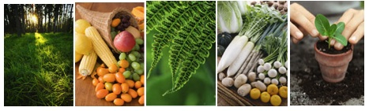
Middle School Unit: Teacher Pages

Environmental Literacy Project
http://edr1.educ.msu.edu/EnvironmentalLit/index.htm

Jennifer Doherty, Lindsey Mohan, Dante Cisterna, and Andy Anderson

April, 2010

Development of these materials is supported in part by grants from the National Science Foundation: Developing a Research-based Learning Progression for the Role of Carbon in Environmental Systems (REC 0529636), the Center for Curriculum Materials in Science (ESI-0227557), Learning Progression on Carbon-Transforming Processes in Socio-Ecological Systems (NSF 0815993), and Targeted Partnership: Culturally relevant ecology, learning progressions and environmental literacy (NSF-0832173). Any opinions, findings, and conclusions or recommendations expressed in this material are those of the author(s) and do not necessarily reflect the views of the National Science Foundation.

Table of Contents
Resources & Acknowledgements 3
Unit Summary 4
Materials list 5
Activity 1: Investigating plant growth 7
Activity 2: Where does a plant’s mass come from? 15
Activity 3: Zooming inside plants (Optional) 24
Activity 4: Plants make their own food 29
Activity 5: Modeling Photosynthesis 36
Activity 6: Where is food stored in plants? (optional) 43
Activity 7: How is food used in plants? 50
Activity 8: Telling a Starch Story (optional account activity 1) 57
Activity 9: Plant Problem-Solving (optional account activity 2) 60
Activity 9: Photosynthesis or Cellular Respiration (optional inquiry) 63

Resources & Acknowledgements

Special thanks to the North Cascades and Olympic Science Partnership (NCOSP) for developing thoughtful activities as part of their Matter and Energy in Living Systems unit. We adapted activities from Cycle 3 of the NCOSP materials for use in our materials. These activities were used with permission from the North Cascades and Olympic Science Partnership, Western Washington University, www.ncosp.wwu.edu. Developed with funding by National Science Foundation Grant No. DUE-0315060.

Thanks to Hui Jin for helping to develop the Process Tool.
Thanks to Jonathon Schramm and Kennedy Onyancha for reviewing and commenting on drafts of these activities.
The following resources were used to develop the activities included in this unit:
Roth, K.J. and Anderson, C. W. (1987, November). The Power Plant: A Teacher’s Guide to Photosynthesis. Occasional Paper No. 112. The Institute for Research on Teaching, Michigan State University.
NCOSP (2007). Matter and Energy in Living Systems.

NutritionData.com (2009) Condé Nast Digital. Accessed April 8, 2010.

Unit Summary
Core Activities
Activity 1: Investigating plant growth: This lesson is designed to elicit students’ initial conceptions of plant growth. Over the course of 1-2 weeks students will observe radish seeds growing in both the light and dark, with and without water. The experiment provides students with an opportunity to think about how plants gain or loose mass at the macroscopic level.

Activity 2: Where does a plant’s mass come from?: Students will review the scientific definition for food and complete an activity Where does a plant’s mass come from? to determine if water, soil, or fertilizers are food for plants. At the end of the activity students should conclude that while plants need water, soil, and sunlight for growth none of these are food and they should hypothesize what they think plants use for food.

Activity 4: Plants make their own food: This is the first lesson to directly introduce the idea of photosynthesis. Many students may be familiar with this process; however, it is likely that they do not understand how matter changes in plant cells. At this point, students should understand that plants cannot get their food from soil, water, or soil minerals/ vitamins, so they are ready to consider the concept that plants make their own food.

Activity 5: Modeling Photosynthesis: This lesson reinforces to students how plants make their own food via photosynthesis. By modeling photosynthesis using manipulatives this activity helps students become more spatially explicit in their thinking about where photosynthesis occurs (i.e. photosynthesis happens in the chloroplasts of leaf cells).

Activity 7: How is food used in plants?: This activity follows up on the question of how plants use the food they make. Students should understand that plants cells need energy and they get it from food. In this activity students learn more about the details of how and why plants use energy. Students also compare this process with those of animals. They will use the process tool to explain the matter and energy changes associated with the use of food for energy and the potato plant poster to be spatially explicit about where energy use occurs.

Optional Activities

Activity 3: Zooming inside plants: Examines the parts of plants at different scales. The activity develops the core idea that plants have many parts and every part is made up of cells.

Activity 6: Where is food stored in plants?: Is a lab experience designed to test for the presence of sugar and starch in different plant parts. This activity reinforces for students that food made in leaves move to plant parts like roots and fruits.

Activity 8: Telling a Starch Story: The purpose of this activity is for students to trace matter and energy through the processes of photosynthesis, biosynthesis, and cellular respiration. Activities 8 and 9 are about accounts, that is, this is a chance for students to develop principle-based explanations about various processes, and to trace materials at the atomic-molecular scale.

Activity 9: Plant Problem-Solving: The purpose of this activity is for students to apply their understanding of photosynthesis and cellular respiration to explain some interesting situations with plants.

Activity 10: Photosynthesis or Cellular Respiration Inquiry: This activity is a supplement to a plant growth inquiry you may already do. Recommended after Activity 4/5 or 7 depending on if you want to focus on cellular respiration or photosynthesis. Students will use the process tool to predict what will happen when they manipulate the intensity of light, the amount of CO₂ or O₂ during photosynthesis or respiration.

Materials list
Have process tool poster or overhead available for each activity. Each activity also requires students handouts that may also be useful to have as overheads or projected via a computer.

Activity 1: Per student group (This lab can be done as a demonstration, if you prefer):

4 Petri dishes or similar
80 Radish seeds
~50 mL water- enough to soak ½ the seeds
Masking tape
Marker
4 Pieces of cheesecloth or similar (big enough to cover Petri dishes)
4 Rubber bands
Scales sensitive enough to weigh seeds about 20 seeds
Weighing boat or small disposable cup
1-2 Paper towels
Drying oven/ dehydrator (oven around 55-60 °C)
4 envelopes for weighing plants (business size works well)

Activity 2:
Sugar cubes
Vitamin tablet (oil, starch, and sugar free)
Plant fertilizer sticks (sugar free) or mix of granulated fertilizer
Lighter, Bunsen burner, or equivalent
Safety goggles for teacher
Tongs

Activity 5: Potato poster and molecular model kits for each student group. Provide each group with 2 large trays or containers so that students can account for all the stuff in tray 1 (reactants) ending up in tray 2 (products). Download photosynthesis animation (time stamp 51:07-53:17) http://www.learner.org/vod/login.html?returnurl=/workshops/energy/workshop5/&pid=1712

Activity 6
For Teacher demonstration:
-Benedict indicator purchased from a chemical supply company (e.g. Carolina.com)
-Hot plate
-Large Beaker or pot partially filled with water
-Tongs
-4 test tubes large enough to stand up in your water container
-A small amount of distilled water, glucose water, apple juice, and carrot juice (diluted so it is mostly clear) - make sure the apple juice contain real fruit juice (i.e. fructose).
Per pair of students:
-Medicine droppers or disposable transfer pipettes
-Iodine-potassium iodide (IKI) solution purchased from a chemical supply company
-1 Small jar (baby food jars) or cup for the iodine solution or dropper bottle
-Foods to test (1 pc per group): bread, potatoes or radishes, bananas, celery stalks, apple or pear, bean
-1-5 Shallow, flat dishes; the number of dishes per pair depends on how many of the 5 tests a student can do on each dish (e.g. Petri dishes, paper or plastic plates)

Activity 7: Download plants growing videos from Environmental Literacy website.

Activity 9: Download annual atmospheric carbon dioxide movie: co2wx_hammer-glb_2008.mov from ftp://ftp.cmdl.noaa.gov/ccg/co2/carbontracker/movies/

Activity 1: Investigating plant growth

General Overview:

First day:
Introduction to Radish seeds ~ 10 minutes
Setting up radish seeds experiment ~ 20 minutes

During the following 10-14 days
Observations 1 ~ 10 minutes
Observations 2 ~ 10 minutes

Second Day:
Observations 3 ~ 10 minutes
Preparing for Drying ~ 20 minutes

Last Day:
Recording final weight ~ 25 minutes
Summarizing results and discussion ~ 30+ minutes
Estimated Time: 2.5 hours (over the course of 1-2 weeks)

Purpose:

This lesson is designed to elicit students’ initial conceptions of plant growth. Over the course of 1-2 weeks students will observe radish seeds growing in both the light and dark, with and without water. The experiment provides students with an opportunity to think about how plants gain or loose mass at the macroscopic level.

Materials:

Copies of Investigating Plant Growth Handout
Per student group (This lab can be done as a demonstration, if you prefer):
4 Petri dishes or similar
80 Radish seeds
~50 mL water- enough to soak ½ the seeds
Masking tape
Marker
4 Pieces of cheesecloth or similar (big enough to cover Petri dishes)
4 Rubber bands
Scales sensitive enough to weigh seeds about 20 seeds
Weighing boat or small disposable cup
1-2 Paper towels
Drying oven/ dehydrator (oven around 55-60 °C)
4 envelopes for weighing plants (business size works well)

Advance Preparation/ Safety Considerations:

- Make copies of Investigating Plant Growth handout
- Collect experiment materials for small groups of 2-4;
- Identify a dark place for students to place their ‘dark’ treatments and a lighted (window with strong sunlight or a fluorescent bulb) place for the ‘light’ treatments. Plants will grow much faster if they are in a warm environment.

Procedures/Suggestions:

Introduction and sharing of initial ideas ~15 minutes

- Divide the students into groups of 2-3 for the experiments. Introduce experiment to students and have them make predictions and answer the questions on page 1 of the handout.

- Have the students carefully read through the procedures before passing out the materials. Make sure the students know how to prepare seeds and get an accurate reading for weight. This is very important!

- Have students complete the procedures for setting up their seeds. Make sure they record the “original weights” for each group of seeds. See the “special note” below for doing a control condition for the class.

- Over the next 10-14 days, select 2 times for students to complete observations 1 and 2. These are descriptive observations. Also, remind students to check their seeds every day or every other day to make sure the “wet treatments” are still damp.

- After 10-14 days the class will need to prepare the seeds for drying. Because water is highly variable in plants, and because it does not count as “tissue mass”, it must be removed for experimental analysis. They should make their third observations and then remove the seeds from the Petri dishes and place in the weighing envelopes. Make sure the students label the envelopes with a group name and the correct treatment condition.

- The teacher will then need to use a drying oven or dehydrator to dry the plants overnight. The timing for drying will vary. A home oven (around 55 °C), radiator, or hot sunny day will also work.

- After the plant material has been dried and returned to students, the students will need to weigh each of the condition (without the envelopes), record the new weight and then calculate the change in weight.

- After completing their data tables, have the students read and discuss the 5 questions at the end of the experiment. Importantly, make sure to leave at least 30 minutes for the class to share and discuss the 5 questions together. It is likely that the students got differences in the weight changes among the different treatments. Importantly, the “dark, water” treatment possibly lost weight, which will be discrepant for students. This can potentially lead to an important discussion about plants using food for energy and where seeds get energy. Have students think about how seeds grow in the dark (they are usually planted underground!) and what is used for energy. There is optional information that you can give to students after the investigations. Keep in mind the following key ideas for the discussion:
- Plants need water and sunlight to gain weight.
- When plants gain weight, they must use materials from outside of their body. Since the radish seeds weren’t growing in soil but still gained weight, plants must get (at least some of) their materials for growth from somewhere else. Where do the students think the materials come from?
- Plants growing without light lose weight.
- All organisms need energy to grow. There is something in plants they can use for energy to grow. Remember from systems and scale, organisms can store chemical potential energy in organic material. These materials must go somewhere during growth as the plant now weighs less. Where do the students think the materials go?

Students will revisit this experiment in Activity 5 and explain their results using knowledge of processes at the atomic-molecular level.

Special note:

Optional for teacher and/or students: Place a 5th batch of seeds in a labeled envelope and place in the drying oven/dehydrator. This batch of seeds will be thoroughly dried to remove any traces of water that might exist in the viable seeds so that you can calculate the true dry weight (biomass) of your seeds in the other treatments. For analysis, you can decide to use the dry mass of this batch to adjust the initial weight of seeds for the other treatments – If the teacher or students do this, make sure to keep track of both the “fresh mass” and “dry biomass” of the seeds. However, seeds are mostly desiccated to begin with so this extra step is not strictly necessary if you think it would be difficult for students.

Student Pages:

Name: __________________________________Period: ______ Date: ____________

Investigating Plant Growth

Plants can grow from tiny seeds into large trees, bushes, and flowers. Brainstorm with your group what you think a plant needs to grow.
_______________________________________________________________________
_______________________________________________________________________
_______________________________________________________________________

Today you will set up an experiment to test some of your ideas about what plants need to grow. Your group will grow seeds in four different experimental conditions and determine which conditions help the seeds grow best. You will set up the experiment today and monitor the growth of your seeds over the next week.

PLEASE KEEP THIS HANDOUT TO RECORD YOUR DATA!

The four experimental conditions you will use are:
  - light + water
  - light + dry
  - dark + water
  - dark + dry

Based on your ideas about what plants need to grow, what do you think will happen to the seeds in each of these conditions in 10-14 days? Record your group’s predictions in the table below:

Experimental Condition | Predictions
Experimental Condition | What will happen to seeds? | Will the weight of the seeds increase, decrease, or stay the same?
Light + water
Light + dry
Dark + water
Dark + dry

Material List:
4 Petri dishes
4 pieces of masking tape, 1 marker
80 radish seeds
~50 mL water
4 pieces of cheesecloth, 4 rubber bands
Scale (to weigh seeds); 1 paper cup or weigh boat
1-2 Paper towels (to pat dry some of the seeds)

Procedures for setting up your seeds after obtaining materials:
Step 1: Prepare containers: Label your 4 Petri dishes using the masking tape and marker. The labels will indicate your 4 experimental conditions. You might also write your group name on the tape so that your containers will not be confused with another group. Make the following labels:
1. light + water
2. light + dry
3. dark + water
4. dark + dry

Step 2: Weighing the Seeds: Divide the seeds into 4 equal piles (~20 seeds in each pile). It is important the groups be equal so you can compare among the four treatments at the end of the experiment. Place each group of seeds in a paper cup to calculate the exact weight of the seeds. Once you weigh each group, place them in one of the four Petri dishes and record the weight in Table 1. Make sure to record the correct weight for each group

Step 3: Watering Seeds for conditions 1 & 3: For the wet treatments (1 and 3), water the seeds thoroughly and allow them to soak for at least 5 minutes to absorb as much water as they can. Drain off excess water after the seeds have soaked using a paper towel to pat the seeds dry, but allow some water to remain on the seeds.

Step 4: Covering the containers: After you have soaked the 2 ‘wet’ treatments and weighed each of the 4 groups of seeds, they should be placed in the Petri dishes. Cover the 4 Petri dishes with a piece of cheesecloth. You will use a rubber band to keep the cloth securely fastened to the container.

Step 5: Placing the containers: Place the containers in the proper areas designated by your teacher. Treatments 1 and 2 will remain in a lighted area; treatments 3 and 4 will be placed in the dark.

Procedures for Maintaining Your Plants
Plants need to be checked daily to track progress and make sure that wet treatments remain moist throughout the experiment. However, you will only need to record observations of your seeds 2-3 times during the experiment using Table 2. Make sure to write complete and accurate descriptions of your seeds. Also be sure to write down what day you made your measurements.
Harvest your plants 10-14 days after planting

Step 1: Your teacher will provide paper “weighing envelopes” for you to put your harvested plant material in. Label the 4 envelopes with your group name and the 4 treatments (light+water, light+dry, dark+water, dark+dry).

Step 2: Carefully transfer all your plant material from the Petri dishes into the envelopes – check to be sure there are no seeds or seedlings clinging to the sides of the Petri dish or in the cheesecloth. Place your sample bags in the area indicated by your teacher. Your teacher will place them in a drying oven/dehydrator and allow them to dry completely (overnight).

Weighing your seeds again

After your plants have dried overnight, you will need to weigh the plant material. Weigh all four treatments. Make sure to weigh only the plants and not the bag too! Record the final weight in table 1. Calculate how much weight was gained or lost by the seeds/plants.

Table 1: Weight of seeds

 | Original weight of seeds | Weight of seeds or growing plants after 10-14 days | Difference in weight
Light & water

Light & dry

Dark & water

Dark & dry

Table 2: Observations of Seeds

 | Observations 1  Date: ______ | Observations 2  Date: ______ | Observations 3  Date: ______
Light & water

Light & dry

Dark & water

Dark & dry

Plant Growth: Data analysis questions

- What was required for radish seeds to sprout?
______________________________________________________________________
______________________________________________________________________

- What was required for radish seeds to gain mass? Why do you think that was?
______________________________________________________________________
______________________________________________________________________
______________________________________________________________________

- Where did the mass come from? How do you think this happened?
______________________________________________________________________
______________________________________________________________________
______________________________________________________________________

- Did any of your radish seeds lose mass? If so, where did the mass go? Why do you think this happened?
______________________________________________________________________
______________________________________________________________________
______________________________________________________________________
______________________________________________________________________
______________________________________________________________________
______________________________________________________________________

- Did the radish seeds grow in the dark? If so, explain where the seeds got their energy?
______________________________________________________________________
______________________________________________________________________
______________________________________________________________________
______________________________________________________________________

Activity 2: Where does a plant’s mass come from?

General Overview:
Small group: Where does a plant’s mass come from? Handout part 1 ~20 minutes
Whole class: Discussion ~10-15 minutes
Whole class: Burning demonstration (optional) ~10-15 minutes
Small group: Where does a plant’s mass come from? Handout part 2 ~20 minutes
Whole class: Discussion ~10-15 minutes

Total Estimated Time: about two 50-minute periods

Purpose:
Students will review the scientific definition for food and complete an activity Where does a plant’s mass come from? to determine if water, soil, or fertilizers are food for plants. At the end of the activity students should conclude that while plants need water, soil, and sunlight for growth none of these are food and they should hypothesize what they think plants use for food.

Materials:
Copies of Where does a plant’s mass come from? Handout
Sugar cubes
Vitamin tablet (oil, starch, and sugar free)
Plant fertilizer sticks (sugar free) or mix of granulated fertilizer
Lighter, Bunsen burner, or equivalent
Safety goggles for teacher
Tongs

Advance Preparation:
Make copies of student handouts if not provided by MSU
Have something to record ideas for Where does a plant’s mass come from? Such as an transparency or e-copy for projector

Procedures/Suggestions:

Small Group: Where does a plant’s mass come from? Handout part 1 ~20 minutes
- Handout Where does a plant’s mass come from? In the first part of the activity students review the scientific definition of food and review Von Helmont’s experiment showing that plants mostly do not use the matter in soil to gain mass (first three pages of the handout). Do a short review with the students after they finish question 5 on the second page. Have students share their predictions about what plants can use for energy and for matter to grow before they move on to the Von Helmont’s experiment.

Class discussion ~10-15 minutes
- Follow the small group work with a whole class discussion over each question.

Whole class demonstration (optional) ~10-15 minutes
- If you choose to do the demonstration do it before proceeding with the last three pages of the handout. Handout optional data table How do scientists find out if there are calories (chemical potential energy) in something? Explain that scientists measure energy in foods using calories and explain that burning food is an indication that there is energy. Remind them about calories from nutrition labels. Have students make predictions before you burn each object. Make sure to ask students WHY they make the predictions they do. You might say: “One way to find out if something has chemical energy is to burn it. If something has a lot of energy, then it will burn. Scientists burn various foods and measure how many calories are in them. Then this information can be put on our food containers so we know how many calories are in the food we are eating. We are going to burn some different materials and see if they have high or low amounts of energy.” Burn each of the three items for the class (‘plant food’, vitamins, and sugar-cubes) and have students fill in the table with their observations and results. Compare this activity with the burning of fuels in the Systems and Scale Unit, emphasizing matter that has high energy bonds will burn.

Small group: Where does a plant’s mass come from? Handout part 2 ~20 minutes
- In the second part of the activity (starting on page 4), students work with a second type of evidence demonstrating soil and water are not food for plants. On the last page they synthesize the information they gathered over the last two classes and apply while interpreting a concept cartoon and also hypothesize what food for plants could be if not soil or water.

Whole class: Discussion ~10-15 minutes
- Follow the small group work with a whole class discussion over each question.

Student Pages:
Name: __________________________________Period: ______ Date: ____________
Where does a plant’s mass come from?
A plant can grow from a tiny seed into a tree, bush, or flower. Where does this mass come from? When an animal gains weight, where does the extra mass come from? That’s right, food. The same is true for plants.
How do plants get food? What is food for plants? If we were to talk about food for humans, we would probably all talk about the same type of things – meat, fish, fruit, vegetables, grains, etc. However, although we might all have ideas about what plants need to grow and survive, we might be less clear on which of these things are considered food. In order to understand what food for plants is and how they get it, you need to remember the scientific meaning of the word “food:”
Food is material that contains chemical potential energy. Living things use the energy in food to live and grow.
There are two important parts to this definition:
1. Food is matter. What do humans, animals, plants and all other living things use the matter in food to do? _____________________________________________________
_______________________________________________________________________

2. Food stores energy (in the form of chemical potential energy). What kinds of things do humans, animals, plants and other living things use the energy in food to do?
_______________________________________________________________________
_______________________________________________________________________

3. The first thing we need to figure out is what can be considered as food for plants; that is, where do plants get energy and matter for growth? Put an X next to the things you think plants use as food.

_______ sunlight
_______ minerals
_______ water
_______ oxygen

_______ chlorophyll
_______ vitamins
_______ leaves

_______ carbon dioxide
_______ carbohydrates
_______ fertilizer (minerals and organic matter)
_______ soil (dirt and organic matter)

4. Explain your thinking when you answered #3. How did you decide if something on the list is food for plants?______________________________________________________
_______________________________________________________________________
_______________________________________________________________________

5. For each of the things you listed in your answer on the first page, which do you think could serve as a source of energy for plants? As matter for growth? If you think a substance provides both matter and energy, be sure to put it in both boxes.
Energy | Matter

Are soil and water food for plants?

Most people would say that plants need water and soil in order to grow, but they may not know what plants get from these things. We will consider several types of evidence in order to determine whether they can be considered food for plants.

Type of Evidence 1:
One of the first people who investigated this idea was a Belgian doctor named Jean Baptiste van Helmont who lived from 1577-1644. In addition to being a doctor, van Helmont did experiments with plants. In 1642, he did a famous experiment to test the idea of whether soil is food for plants.

1. Suppose a child was given a plate with 20 pounds of food to eat as quickly as they could. Predict what would happen to the weight of that child as he or she ate the food. Would the child’s weight go up, go down, or stay the same? What would happen to the weight of the food as the child ate it? Would the weight of the food go up, go down, or stay the same? Write your predictions in the table below.

Predict: Eventual weight of child | Predict: Eventual weight of food on plate
2. Now think about a young tree growing in a bucket of soil.
- Over time, will the tree’s weight go up, down, or stay the same?
- If soil is food for plants, would the weight of the soil go up, down, or stay the same?
- If soil is not food for plants, would the weight of the soil go up, down, or stay the same? Record your predictions in the table below.
Predict: Eventual weight of tree | Predict: Eventual weight of soil
 | If soil is food | If soil is not food

Von Helmont planted a 5-pound young tree in a bucket containing 200 pounds of soil. He watered the tree regularly but he did not add any more soil. After 5 years he weighed the tree and bucket again. Here are his results:
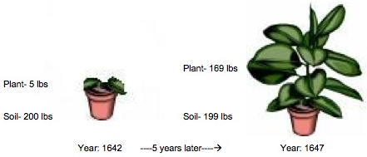
3. Look at the diagram of Von Helmont’s experiment. Can you figure out if the tree or soil lost or gained weight in the 5 years that the plant grew?
Weight Change of Tree | Weight Change of Soil

4. What does Von Helmont’s investigation tell you? Is soil food for plants? Why or why not?__________________________________________________________________________________________________________________________________________
Type of Evidence 2: Anything the U.S. Food and Drug Administration defines as food is required by law to have a nutritional label that provides information about the total calories; the amounts of fat, protein, and carbohydrate; and information about components known to impact health (e.g. saturated fats, cholesterol, fiber, calcium, and iron). In addition to labels on items that are considered food, the FDA also requires labels on things like vitamins and minerals that are considered “dietary supplements.”
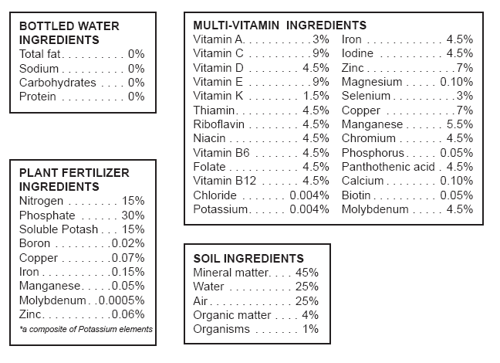
Using nutritional labels and other packaging information, you will compare the contents of food, water, dietary supplements, soil, and plant fertilizers (often casually called “plant food”). For your analysis, you will look at three factors: energy content (represented by calories), matter used as building blocks for growth (represented by fats, proteins, carbohydrates), and minerals (such as calcium, iron, magnesium, zinc, and manganese) that are important for optimizing cellular processes.

1. Examine the package labels from the items listed on the next page and use the information to fill out the data table. Record your answers as lots, little, none, or ND for “not determined.” Use what you know about human food for the last row.
Item | Provides useful energy | Contains building blocks for growth | Contains minerals
Water
Soil
Multi-vitamin with minerals
“Plant Food” or Fertilizer
Human Food
2. Water and “plant food” or fertilizer are two things that plants need in order to grow well. Based on your analysis, do either of these things fulfill the scientific definition of food? What is your evidence?
______________________________________________________________________________________________________________________________________________
_______________________________________________________________________

3. Compare the contents of plant food to those of human food and the multi-vitamin with minerals. Do products labeled “plant food” seem to be more like human food or more like a mineral supplement? What is your evidence?
______________________________________________________________________________________________________________________________________________
_______________________________________________________________________

4. Compare the typical composition of soil to food and the multi-vitamin with minerals. Does soil seem to be more like human food or more like a mineral supplement? What is your evidence?
______________________________________________________________________________________________________________________________________________
_______________________________________________________________________

5. What is the most likely function of soil and plant fertilizers in plant growth?
______________________________________________________________________________________________________________________________________________
_______________________________________________________________________

6. Could the tree live and grow if all it took in from the environment was water? Why or why not? _______________________________________________________________
_______________________________________________________________________
_______________________________________________________________________

Summary Questions
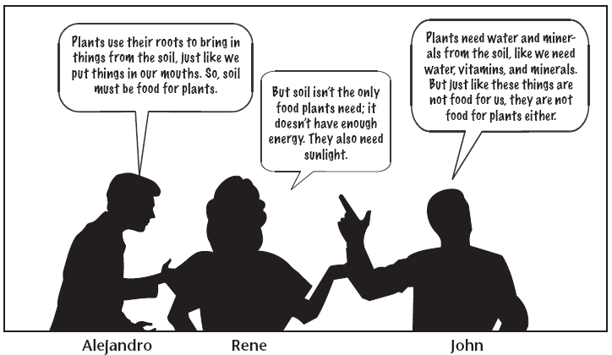
- Three friends are discussing how plants get energy to live and grow. Which student do you agree with? Explain your reasoning.
______________________________________________________________________________________________________________________________________________
_______________________________________________________________________

2. If water, soil minerals, and sunlight are not food for plants, what do you think is food for plants?
______________________________________________________________________________________________________________________________________________
_______________________________________________________________________

How do scientists find out if there are calories (chemical potential energy) in something?
One way to find out if something has chemical chemical energy is to burn it. If something has a lot of energy, then it will burn. Scientists burn various foods and measure how many calories are in them. This information can be put on our food containers so we know how many calories are in the food we are eating. We are going to burn some different materials and see if they have high or low amounts of energy.

 | Vitamin pill | Plant food | Sugar cube
Do you think it will burn?
Why?
Observations during demonstration | It didn’t burn | It didn’t burn | It burned
Does it have chemical energy? | No | No | yes
Could it be food for plants?  (using the scientific definition) | No | No | yes

In order to conclude whether the sugar cube, vitamin pill, and “plant food” stored chemical potential energy, what evidence did you use?
______________________________________________________________________________________________________________________________________________
_______________________________________________________________________

Activity 3: Zooming inside plants (Optional)

General Overview:
Introduction ~7 minutes
Working with plant cards ~7 minutes
Summary questions and review ~7 minutes

Total Estimated Time: ~20 minutes

Purpose/Background:
The purpose of this lesson is to help students visualize the relative size of plants and their parts from the landscape to the microscopic scale and to introduce/reinforce the fact that all plant parts are made up of cells. The students already know that plants are living things, but it might be difficult for them to understand plants have an internal organization made of cells. The rest of the unit is designed to help students understand that the processes that plants perform and their use of materials occur inside of cells. For example, in activity 4 students will learn that photosynthesis occurs in leaves and specifically in the cells of leaves. In activity 6 they learn that the things plants need from the environment move to different plant parts and they are used in plant cells.
The goals of this activity are that students understand:
-Plants and their parts (e.g. leaves, stems, and roots) are made up of cells.
-The things that plants need are used inside the plant’s cells.

Materials:
Copies of Zooming into Plants handout
Card sorting packets (1 per pair or group)

Advance Preparation/ Safety Considerations:
Make copies of all student handouts if not provided by MSU
Make overhead transparencies if needed and not provided by MSU

Detailed Procedures:

Introduction 7 minutes

1. Introduce the activity by having students review the benchmark scales they learned about in the System and Scale Unit. Ask students to name different things presented in previous units and their different sizes, or the scales in which they can be classified. Remind students that they classify the size of things in three categories: those that are too large to see with the human eye, those that we can see with our eyes, and those too small to see with the human eye. Ask students for examples of each category.

2. Tell the students that today they will continue to focus on plants and learn how plants and their parts can be classified at the different scales. Review with them the different parts of plants (e.g. leaves, stems, and roots).

Working with plant cards 7 minutes

1. Pass out a copy of the Handout Zooming inside plants to every student and ask them to respond to the first question. Review the question explaining that they are familiar with these parts because they can be seen with our eyes.

2. Students will now work with a set of cards that present pictures of plants at the three scales. They have pictures of different plant parts (e.g. roots, leaves and stem/branch) and scales (landscape, macroscopic and microscopic/atomic-molecular). Organize the class in groups of 2 or 3 students and pass out the packets of cards. Ask students to classify the cards according to plant part (for this have the students set aside cards 2, 3 and 4, or just don’t hand out those cards until instruction 4 below).

3. Discuss student classifications and explain to the students that every part that we can see is made up of cells that we can’t see with our eyes. Tell the students that all the things that plants need have to move inside cells. Have students complete the first chart on their handout, writing the card number for each category.

4. Now have students classify the cards according to their scale. Discuss the student classifications and correct as necessary. Explain to them that every part of the plant has cells, even though the cells’ functions will vary within the plant.

Summary Questions and Review 7 minutes

1. In their groups have students complete questions 4 and 5 on the handout. Once they finish, lead a class discussion on their responses.

2. Finally, review with the students the main goals of this activity:
-Plants and their parts (e.g. leaves, stems, and roots) are made up of cells.
-The things that plants need are used inside the plant’s cells.
Name: ____________________________________________ Date: ______________
Zooming into plants
When we are walking in a place like a forest we can see many kinds of plants, like tall trees, shrubs and grasses and they all look different. However, if we look at this forest flying in a plane, we would not easily be able to tell the difference between different kinds.
1. While we are in the forest we are able to see different parts of the plants. Please name some plant parts that you know. ____________________________________________
Examples: roots, stem, branches, leaves_____________________________________

Working with plant cards
2. In the chart write the numbers of the pictures according to their plant part.
ROOT | STEM/BRANCH | LEAF
6, 8 | 1, 9 | 5, 7

3. In the chart, write the numbers of the pictures according to the closest scale.
TOO SMALL TO SEE WITH HUMAN EYE  (microscopic and smaller) | CAN SEE WITH OUR EYES  (macroscopic, visible) | TOO LARGE TO SEE WITH HUMAN EYE  (Landscape scale)
5, 6 , 9 | 1, 2, 4 ,7 ,8 | 3

4. Though we can see the different plant parts, we can’t see what the parts are made of. If we could, what would we see?____________________________________________

5. You know that plants need some things in order to grow. Do their cells need these things too? Why do you think that?
Cells are alive and have activity and they need materials too. ______________________________________________________________________
Cards for sorting
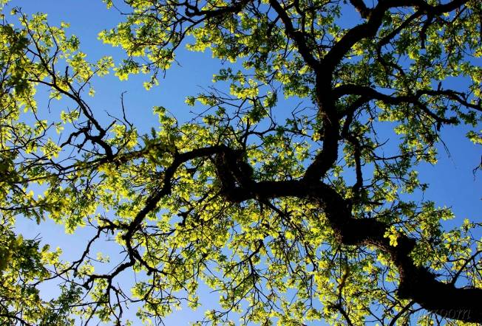
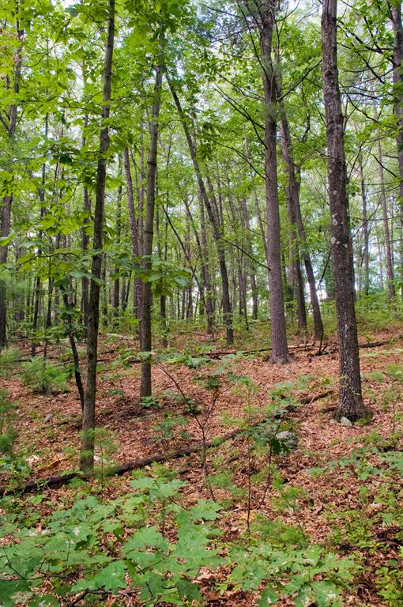
1. Tree branch
2. Forest

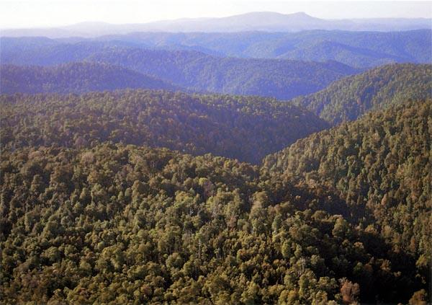
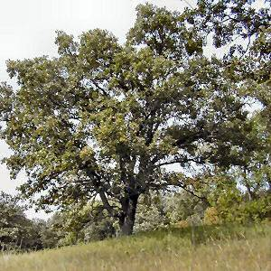
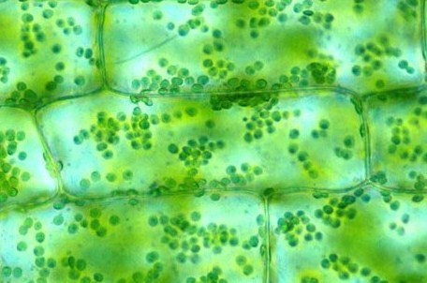
3. Ecosystem
4. Tree
5. Plant leaf cells

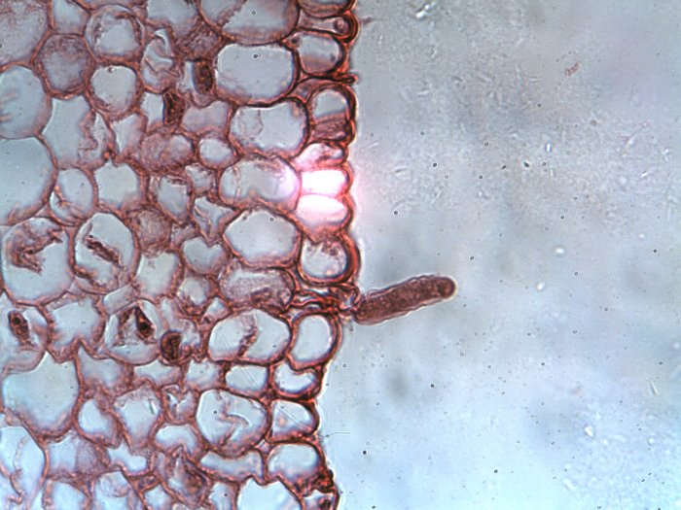
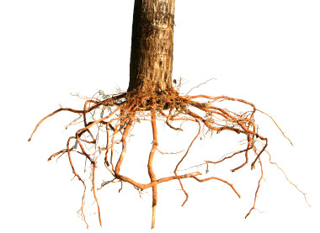
6. Plant root cells
8. Plant root

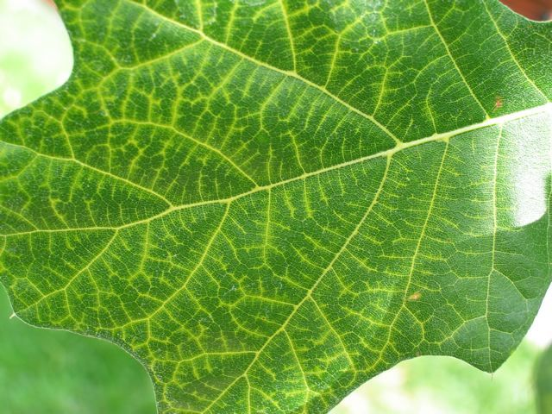
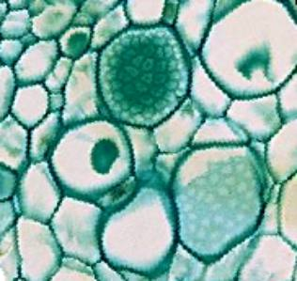
7. Tree leaf
9. Plant stem cells

Activity 4: Plants make their own food

General Overview:
Whole class reading: What is photosynthesis? ~20 minutes
Individual/Small Group questions & discussion ~20 minutes

Total Estimated Time: 40 minutes

Purpose/Background:
This is the first lesson to directly introduce the idea of photosynthesis. Many students may be familiar with this process; however, it is likely that they do not understand how matter changes in plant cells. At this point, students should understand that plants cannot get their food from soil, water, or soil minerals/ vitamins, so they are ready to consider the concept that plants make their own food. There are three critical ideas that students must understand from today’s lesson:
- Non-energy containing molecules (carbon dioxide and water) go to cells and plants use sunlight (light energy) to make energy-rich food molecules; sugar/glucose.
- Food plants make is what allows them grow and gain weight and allows their cells do work/function.
- Light energy is transformed into the chemical potential energy stored in food.

Materials:
Copies of What is Photosynthesis?
Overhead transparencies or e-copies for projector for discussion

Advance Preparation/ Safety Considerations:
Make copies of all student handouts if not provided by MSU
Make overhead transparencies if needed if not provided by MSU

Detailed Procedures:

1. Whole Class Reading ~15-20 minutes
Handout the reading What is photosynthesis? Today students will discuss photosynthesis. During Activity 2, students have explored whether water, soil, or minerals are “food” for plants. Today the students will talk about the role of sunlight and the process of photosynthesis. The reading today provides a lot of information for students, so it will be necessary to stop at several points to point out key ideas, as suggested below:
- After the first paragraph discuss students’ ideas about why sunlight cannot be food for plants. It’s important that students realize sunlight is energy, but it’s not a material--explained in the next paragraph.
- The box on the first page introduces the idea that plants make food. At this point ask students if they knew plants make their own food, and what they know. Tell students they are about to learn how plants get the food they need to make their cells work.
- The last paragraph on the first page introduces the process of photosynthesis. Stop to check whether students understand “carbon dioxide” is a gas (and a material/matter). After reading the explanation of photosynthesis, explain to students that the molecules of water and CO₂ do not have much energy, but that plants combine the two using sunlight energy to make sugar, which has lots of energy. So water and CO₂ are materials, and sunlight is energy, and when combine you have an energy-rich material called sugar. And, importantly all of this happens in cells in plant leaves that contain chlorophyll. In this unit we focus on plant leaf cells performing photosynthesis. A complication you ma or may not want to introduce is that all cells that contain chlorophyll are capable of performing photosynthesis (e.g. green stems, fruits).
- At the end, students learn that plants make the sugar to help their cells grow and function like other living things. Tell students they will learn more about this later.

2. Small Group/ Individual questions then discussion 20 minutes

Handout the student worksheet Plants make their own food. Give students about 10 minutes to complete the process tool and answer the questions. Have them try these first individually. Then have students discuss these three questions as a class. The questions focus on whether students understand how water and carbon dioxide are necessary for making glucose. Students should learn that a plant’s weight comes from the glucose it makes, and before that the sugar was water and carbon dioxide. So some of the plant’s weight originally comes from the CO₂ in the air!

Student Pages:

What is photosynthesis?

What conditions in your radish experiment did your seeds need to gain mass? Does this mean that sunlight is food for plants? Remember, food is always matter that contains energy for living organisms. Water, soil, and minerals are things that plants need, but they are not food because they do not contain energy living things can use to live and grow. Sunlight is a kind of energy plants use, but sunlight is not food for plants because sunlight is a kind of energy, not matter. But sunlight does have something very important to do with food for plants. Scientists have found that plants are able to do something with the sun that humans or animals cannot do:

Plant can use the light energy of sunlight to make their own food in their leaves.

You can use a chemical test to see if a plant is making food. If you boil a leaf in ethanol to get rid of the green color, you can use iodine to stain the food the plant makes. If there is food being made, the leaf will turn purple. This test was used on radish seedlings just like yours. The figure below shows the radish seedlings made food in the light but not in the dark.
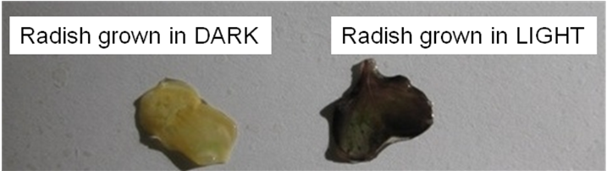
How do plants use sunlight?
In order to make energy-containing food, plants need two types of matter: water and carbon dioxide. Carbon dioxide is a gas that is in the air. Plants take in the water molecules from the soil. Water travels from the roots up tubes inside the plant. The water reaches the cells in the leaves. Carbon dioxide enters the leaves through tiny holes in the leaves.
The figure below shows the results of the iodine test again used on radish seedlings. This time both plants were grown in the light but one was covered in Vaseline so carbon dioxide could not get inside the leaf cells. Only the plant that had carbon dioxide from the air going into the leaf cells was able to make food.
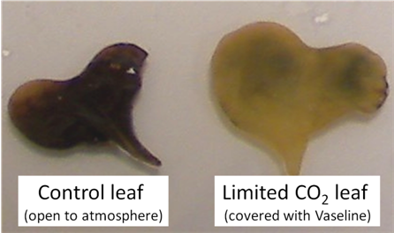
Inside the leaf cells of plants is a molecule called chlorophyll. Chlorophyll has the ability to capture the energy of sunlight. The light energy then breaks the bonds holding the atoms together in the water and carbon dioxide molecules. The atoms form new molecules of oxygen and a sugar called glucose, which the plant can use for good. In this process the light energy from the sun is changed (transformed) into chemical energy that’s stored in the glucose molecule.
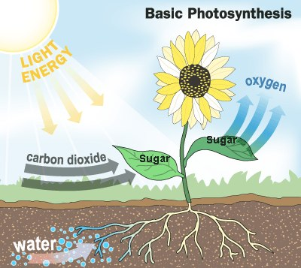
Photosynthesis
This process of making sugar is called photosynthesis. “Photo” means light and “synthesis” means putting together.
Photosynthesis makes only one kind of food: a sugar called glucose.

Sometimes scientists use equations to represent processes, such as photosynthesis.

A verbal equation for this change in matter is:

water and carbon dioxide turn into glucose and oxygen

The same equation written with the chemical symbols for the atoms:

6 H₂O + 6 CO₂ → C₆H₁₂O₆ + 6 O₂

As you can see from the equation above, glucose is composed of carbon, hydrogen, and oxygen atoms – the very same carbon, oxygen, and hydrogen atoms that were originally found in the carbon dioxide and water. However, the energy of sunlight (light energy) has been captured in the bonds between these atoms (chemical energy) in the glucose molecules.

The leaf cells can use the food they make, but the food can also travel from the leaves to all other parts of the plant. Getting food from leaf cells is the only way in the cells in the roots or stems or flowers can get the energy-containing food they need.

Plants use the glucose they make for two purposes. First, the glucose can be combined with other molecules that the plant has made or with minerals taken up from the soil to produce carbohydrates, fats, and proteins. The plant uses these carbohydrates, fats, and proteins to build cells in the roots, stems, leaves, flowers, and fruits. In this case, the plant is using the food as a source of matter. The second way that plants use the glucose they make is for energy. Cells can release the stored energy in food so it can be used to power cell functions. Plants can store food before using it for energy. When plants store food, they usually change it from glucose to some other kind of food, such as starch. All the food on earth started out as sugar made by plants!

Name: __________________________________Period: ______ Date: ____________
Plants make their own food

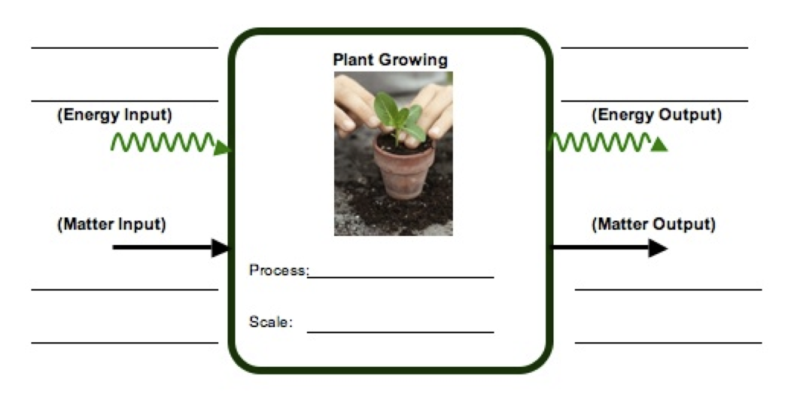
1. When plants make their food, they change matter and energy. Use the matter and energy process tool to show how plants change matter and energy.
Photosynthesis

Now try to use these ideas about how plants make food to explain the following situations:
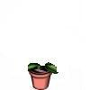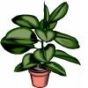
- Think about Von Helmont’s experiment: The tree gains 164 pounds after 5 years. Where did the weight of the tree come from? _______________________________
_________________________________________________________________________________________________________________________________________________________________________________________________________
- A drop of rain falls into the soil near the roots of a large plant. Describe what will happen to that water if it is taken into the plant. If it enters the roots, where will it travel, and what may happen to it? _______________________________________
_________________________________________________________________________________________________________________________________________________________________________________________________________

- Some plants were put in soil, given water, and placed in a tightly sealed bottle so they could not get any air. The bottle was placed in the sunlight. Will the plant in the jar be able to make food?______________________________________________
_________________________________________________________________________________________________________________________________________________________________________________________________________

Activity 5: Modeling Photosynthesis

General Overview:
Review photosynthesis ~5 minutes
Photosynthesis modeling ~30 minutes
Class review ~10 minutes

Total Estimated Time: 45 minutes

Purpose/Background:
This lesson reinforces to students how plants make their own food via photosynthesis. By modeling photosynthesis using manipulatives this activity helps students become more spatially explicit in their thinking about where photosynthesis occurs (i.e. photosynthesis happens in the chloroplasts of leaf cells). There are three main ideas students should understand from this activity:
- Plants make glucose in leaf cells using molecules of H₂O from the soil, molecules of CO₂ from air, and sunlight.
- The atoms in water and carbon dioxide are eventually the atoms of glucose and oxygen.
- The light energy from sunlight is transformed into the chemical energy in glucose.

Materials:
Copies of Modeling Photosynthesis handout
Molecular model kits from Systems and Scale Unit
Overhead transparencies or e-copies for projector for discussion

Advance Preparation/ Safety Considerations:
Make copies of all student handouts if not provided by MSU
Make overhead transparencies if needed if not provided by MSU
Download photosynthesis animation (see below).

Detailed Procedures:
Review 5 minutes
Briefly review the process of photosynthesis. You may want to use the process tool to review the teaching points from Activity 3.

Modeling Photosynthesis 30 minutes
Pass out model kits to groups. Students will first build water and carbon dioxide, answering questions about the type of atoms and bonds. They will then rearrange these into glucose and oxygen. They need to be aware that matter is conserved and that light energy from the sun is transformed into chemical potential energy in glucose. Have students respond to several key questions throughout the handout. You may want to use an animation of photosynthesis at the molecular level before your students attempt their modeling (time stamp 51:07-53:17) http://www.learner.org/vod/login.html?returnurl=/workshops/energy/workshop5/&pid=1712

Class Review 10 minutes
Make sure to at least discuss questions 20 and 21 before the class period ends.

Modeling Photosynthesis

Recently you learned how plants make their own food from molecules of water and carbon dioxide using the energy from sunlight. Today you are going to model this food-making process, photosynthesis, in a potato plant.

- What benchmark scale can we use to classify a potato plant?
The macroscopic scale. __________________________________________________

- What benchmark scale can we use to classify the leaf cells of a potato plant?
The microscopic scale. ___________________________________________________

- On the potato plant poster, you can see that parts of the root, stem, potato, leaf, and fruit have been zoomed in on and drawn 100s of times bigger than they are. If we really wanted to see the leaf cells of a plant what kind of tool would we have to use?
A microscope. __________________________________________________________

- The cells of the potato plant have been zoomed in on even farther so you can show water, carbon dioxide, glucose and oxygen molecules moving around inside the plant. Could you see a molecule of glucose if you use a microscope to look inside a plant cell? Why or why not?
No, molecules are at the atomic-molecular scale and are too small to be seen with a microsope. _________________________________________________________

In your groups, you will use molecular model kits to model the process of photosynthesis. You will build the substances that go into cells, and then use the models to show how those substances change inside cells.
The chemical composition of glucose is C₆H₁₂O_{6.} This means that in one molecule of glucose there are:
6 atoms of carbon 12 atoms of hydrogen 6 atoms of oxygen

- Where do these atoms come from to make a molecule of glucose inside the plant?
The environment, carbon dioxide in the air and water in the soil

- Carbon dioxide molecules contain 1 carbon atom and 2 oxygen atoms. How many carbon dioxide molecules (CO₂) does it take to make one molecule of glucose? (Hint: focus on how many carbon atoms you need to make a glucose) ______
CARBON DIOXIDE MOLECULE

- Carbon dioxide molecules look like the diagram on the right. Build 6 CO₂ molecules. Place them where they are before they enter the plant.

- Physically move the molecules to the leaves. Make sure to move the molecules to the atomic-molecular scale expansion of the leaf cell. Carbon dioxide gets into leaf cells through tiny holes in the leaf. Move the carbon dioxide molecules to the tiny hole and into a leaf cell.
WATER MOLECULE
- Water molecules contain 1 oxygen atom and 2 hydrogen atoms. How many water molecules (H₂O) does it take to make one molecule of glucose? (Hint: focus on how many hydrogen atoms you need to make a glucose) ______

- Water molecules look like the diagram on the right. Build 6 water molecules. Place them where they are before they enter the plant.

- Water gets into leaf cells by traveling from the roots, through the stem, and then into the leaf. The plant has special cells that act like tubes to move water quickly. They are blue on your poster. Move the water molecules from the soil and into the same leaf cell that has the carbon dioxide molecules.

- Look at the bonds in the water molecule. What type of bonds are they (i.e. C-C, C-H, C-O, H-O, or O=O)? Are they high energy or low energy bonds?
_____________________________________________________________________
_____________________________________________________________________
- Look at the bonds in the carbon dioxide molecules. What type of bonds are they? Are they high energy or low energy bonds?
_____________________________________________________________________
_____________________________________________________________________

Complete the table below summarizing the molecules you have just made:
 | Matter |  |  | Energy
 | # Carbon atoms | # Oxygen atoms | # Hydrogen atoms | High or Low Energy Bonds
Water
Carbon Dioxide
Total Atoms |  |  |  | LEAVE BLANK

- Using the information above, do you think either of these substances supply energy for plant cells to work?

- Using light energy, enzymes in a plant’s leaf cells combine carbon dioxide and water molecules to make glucose and oxygen molecules. First, you will break apart the carbon dioxide and water molecules and build a glucose molecule from the atoms. Then you will build oxygen.

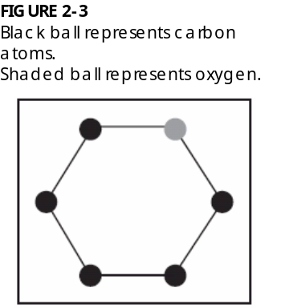
- Build a glucose molecule:

Step 1: Build the Glucose Ring. Look at the diagram to the right. This shows the first part of the glucose molecule. It shows 5 carbon atoms (black) and 1 oxygen atom (grey). This ring will start your glucose molecule

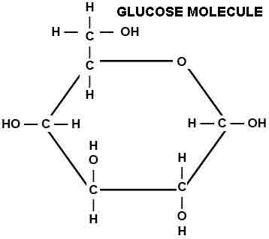
Step 2: Look at the diagram and circle on the right. You will work first with the carbon that is to the left of the oxygen in your ring. On this carbon, first connect a second carbon. On this second carbon, attach 2 hydrogen atoms and 1 oxygen. Attach another hydrogen to the oxygen. Then attach 1 hydrogen to the carbon that is on the ring. There should be no empty holes.

Step 3: Move to the next two carbons on the ring. Attach 1 oxygen and 1 hydrogen to these carbons. Then attach another hydrogen to each oxygen. Make sure it looks similar to the diagram to the right. There should be no empty holes on these atoms.

Step 4: Move to the last two carbons on the ring. Attach 1 oxygen and 1 hydrogen to these carbons. Then attach another hydrogen to each oxygen. Make sure it looks similar to the diagram to the right. There should be no empty holes on these atoms.

Check that there are no empty holes on your glucose molecules and that it looks like the diagram. Now you’re ready to build your oxygen molecules!

17. Build 6 oxygen molecules.

Step 5: With the remaining oxygen atoms, build 6 oxygen molecules. You should have 12 oxygen atoms left over, and this will make 6 oxygen molecules. Each molecule contains 2 oxygen atoms. These are bonded together twice (a double-bond). Build 6 oxygen molecules that look like the molecule on the right.

Once you have made your glucose and oxygen molecules, count the number of atoms in these molecules. Look at the bonds in the glucose and oxygen molecule. What type of bonds are they? Are they high energy or low energy bonds? Complete the table below.
 | Matter |  |  | Energy
 | # Carbon atoms | # Oxygen atoms | # Hydrogen atoms | High or Low Energy Bonds
Glucose
Oxygen
Total Atoms |  |  |  | LEAVE BLANK

Check to see that you have the same number of atoms that you started with. There should be no extra atoms either. All of the atoms you began with should be part of either the glucose or oxygen molecules. Remember atoms cannot be created or destroyed!
 | Matter |  |  | Energy
 | # Carbon atoms | # Oxygen atoms | # Hydrogen atoms | High or Low Energy bonds
Began with…
(Carbon dioxide and Water)
End with… (Glucose and Oxygen)

- Oxygen leaves the leaf cells the same way carbon dioxide enters. Move the oxygen molecules out of the leaf in the model.

- The plant has special cells that move sugar around the plant’s body quickly. They are orange on your poster. Where can glucose move to in a plant?
Roots cells, stems cells, flowers cells, fruit cells, potato cells, other leaf cells… anywhere. Sugar can also stay in the leaf cell where it was made.______________
___________________________________________________________________
Move the glucose molecule you made into one of the locations you listed above.

- What could the glucose molecule be used for in this location?
______________________________________________________________________________________________________________________________________

- Suppose you heard someone claim that most of a plant’s mass came originally from carbon dioxide in the air. Do you agree with this person? Explain your answer.
__________________________________________________________________________________________________________________________________________________________________________________________________________________
______________________________________________________________________
______________________________________________________________________

- You modeled photosynthesis as a process where plant cells take low-energy substances and rearrange the atoms into a high-energy substance (glucose). Where do plant cells get energy for this process and how does energy change?
______________________________________________________________________
__________________________________________________________________________________________________________________________________________________________________________________________________________________
______________________________________________________________________
______________________________________________________________________

Activity 6: Where is food stored in plants? (optional)

General Overview:
Introduce the investigation: Where is food stored in plants? ~5 minutes
Explain materials and practice with bread ~10 minutes
Complete the investigation ~30 minutes
Class discussion of the investigation ~20 minutes
Estimated Time: 65-75 minutes

Purpose:
This lab activity is designed to focus students’ attention on the idea that the food made during photosynthesis travels from the leaf to all parts of the plant where it can be used as food or stored for later. Students should already understand that plants make food that is used either for growth or to get energy for life processes. Today students will test different plant parts for starch and sugar. They complete the starch testing, because of its simplicity while the sugar testing can be done as a demonstration. The questions that accompany the activities are an important part of the lab. They involve students in tracing the food made in the leaf during photosynthesis to several parts of the plant. Most likely students have not thought about how the food in a potato got there. With their new understanding of photosynthesis they can explain what is happening inside the plant and the plant’s cells.

Materials:
Student copies of Where is food stored in plants? and overheads if needed
For Teacher demonstration:
-Benedict indicator purchased from a chemical supply company (e.g. Carolina.com)
-Hot plate
-Large Beaker or pot partially filled with water
-Tongs
-4 test tubes large enough to stand up in your water container
-A small amount of distilled water, glucose water, apple juice, and dilute carrot juice (so it is mostly clear) - make sure the juices contain real fruit juice: glucose
Per pair of students:
-Medicine droppers or disposable transfer pipettes
-Iodine-potassium iodide (IKI) solution purchased from a chemical supply company
-1 Small jar (baby food jars) or cup for the iodine solution or dropper bottle
-Foods to test (1 pc per group): bread, potatoes or radishes, bananas, celery stalks, apple or pear, bean
-1-5 Shallow, flat dishes; the number of dishes per pair depends on how many of the 5 tests a student can do on each dish (e.g. Petri dishes, paper or plastic plates)
Advance Preparation/ Safety Considerations:
Make copies of Where is food stored in plants?
Make overheads if necessary, especially of the starch chart, diagrams of plants
Soak bean seeds in water for 24 hours
Prepare materials (slice fruits, veggies)
Prepare indicator solutions. Be careful because iodine stains hands and clothing.

Detailed Procedures:
1. Introduce the lab investigation to students. At this point it may be good to remind students of what they know about photosynthesis and how plants make food (sugar). Additionally remind them about the model of photosynthesis they worked on in Activity 6. They learned that sugar is made in leaf cells and later it moves to other parts of the plant.

2. Demonstrate the lab method using the sugar indicator solution (Note, you should be able to do this with chunks of vegetables and fruit and even spinach or lettuce leaves, if you want to test more than the 4 items). Add about 3 ml of (more if you want) of both the test solution and Benedicts indicator. Place the test tubes in a boiling bath for 2-3 minutes. Remove using the tongs, and allow students to record their observations of the sugar test.

3. Ask students what the results of the sugar test demonstrate: plants move sugar from where it is produced in the leaves to other parts of their bodies.

3. Read over the handout introduction with students and talk briefly about the differences between sugars and starches. Make sure that students understand that starches are made by plants by combining sugars and that plants make starch to store food for later.

4. Demonstrate the lab materials to students and put the students in groups. You may want to use a test tube of water and one of starch mixed with water to demonstrate to students what color iodine turns when in the presence of starch. Once students understand what to do in the lab investigation, give each group a plate and iodine with dropper. Have them first practice using a piece of bread. Then have them complete starch tests using a underground storage organ (potatoes or radishes), two fruits (bananas and apple or pear), a stem (celery stalks), and seed (bean).

5. As students conduct the investigations in groups, they need to follow the instructions in the lab handouts and fill in a data table with prediction, observations and conclusions. The table can be used for discussion during or after the lab investigation.

6. At the end of the lab investigation, students should first clean up their materials. Then have students work in groups to respond to the Making Sense of the Experiment questions.

Key points to make during and after the lab:
- Plants make sugar during photosynthesis and then starches from sugar to use for food.
- The reason we say sugar and starch are energy-rich materials is because plants have stored some of the energy from the sun in those materials.
-Plants get all their food by making it inside their leaf cells. Only certain cells in the plant can make food.
- All other plant cells, for example cells in seeds, stems and roots, must get their food from leaf cells where the food is made. Extra sugars made by the plant are stored in the form of starch.
Name: __________________________________________ Date: _______________

Where is food stored in plants?

In this activity you will test different plant parts to see if they contain food made by the plant during photosynthesis. As you know, plants make sugar for food during photosynthesis and can transform that sugar into other materials that plant may need. One important material is starch. Plants cells can make starch by putting together long chains of sugar. Plant cells convert extra sugar to starch to store the food for later. Today you will test where starches and sugars can be found in some of the fruits and vegetables we eat.

1. Why are sugar and starch considered food for plants?
According to the scientific definition of food, food is a material that has chemical energy. Both sugar and starch are materials that store chemical energy.
____________________________________________________________________

2. Where in the plant is sugar made?
In the cells of plant leaves.
____________________________________________________________________

3. How does sugar move from where it’s made to other parts of the plant’s body?
In the specialized transport cells to other parts of the plant.
____________________________________________________________________

Demonstration of Sugar Test:
Your teacher will conduct a short demonstration for your class. In this demonstration your teacher is testing for the presence of sugar in different solutions. Before the demonstration, record your predictions about which materials contain sugar in the table below. Then watch as your teacher heats the solutions and record your observations. Then draw some conclusions about your observations.
 |  | PREDICT | OBSERVE | CONCLUDE
Material | Plant Part | Do you think this material contains sugar? | Description/drawing of what happened in the test tube | Does this material contain sugar? | Does this material store chemical energy?
Water |  | No | Stuff in test tube didn’t change color. | No | No
Sugar water |  | Yes | Stuff in test tube turned orange. | Yes | Yes
Apple Juice | Fruit | Yes | Stuff in test tube turned orange. | Yes | Yes
Carrot Juice | Root | Yes | Stuff in test tube turned orange. | Yes | Yes

4. If the apple or carrot contains sugar, how did the sugar get to those plant parts?
Sugar is made in leaf cells and moved until it reaches the fruit or leaf cells
_____________________________________________________________________

Testing Foods for Starch
Before testing parts of the plants for starch, you need to take a few precautions when using the iodine indicator. Iodine IS a toxic substance. During the lab, do not touch your eyes/mouth/nose, etc., if you have been handling the iodine. Iodine will stain clothes and skin, so be very, very careful.
When testing a material for starch, place the material on a plate. Using a dropper, place a few drops of iodine solution on the material. Iodine solutions turns blue-black or purple in the presence of starch. Make predictions with your group BEFORE you test each material.
 |  | PREDICT | OBSERVE | CONCLUDE
Material | Plant Part | Do you think it contains starch? | Description/drawing of what happened in the test tube | Does it contain sugar? | Does it store chemical energy?
Bread | made from flour which is ground up wheat seeds |  | Iodine solution changed its color | Yes | Yes
Potato or radish | Root (or belowground storage part) |  | Iodine solution changed color | Yes | Yes
Banana | Fruit |  | Iodine solution changed color | Yes | Yes
Apple | Fruit |  | Iodine solution changed color | Yes | Yes
Celery | Stem |  | Iodine solution didn’t change color | No
Bean | Seed |  | Iodine solution changed color | Yes | Yes
5. Which parts of a plant that you tested contained food stored as starch?
Seeds, roots (belowground food storage) and fruits _____________________________
6. What is starch made of?
Starch is made up of sugar. _______________________________________________

7. Where did the chemical energy stored in the starch come from?
The energy in sugar comes from sunlight. ____________________________________

8. Can the cells of plant roots make food? __No____ Why or why not?
No, because root cells don’t receive sunlight. They can’t do photosynthesis.

9. When you eat a banana or a potato, where did the food stored in the banana or potato cells originally come from?
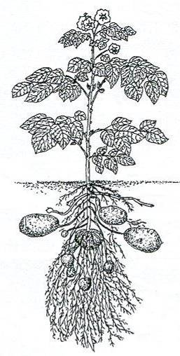
It came from cells in the leaves and it was transported in special sugar transporting cells to the banana or potato cells. ____________________________________________

In the figure of the potato plant, draw arrows to show how the food stored in starch got to the potato.

5. When we eat plant parts, such as fruits and vegetables, we eat energy-rich food (starch and sugars) that the plants have made and stored. Did the plants make it for us? __No_____ (yes or no)

6. Why you think the plants make the energy-rich starch and sugars? Because they need matter and energy for their cells in order to grow, to move, to transport materials, and to reproduce (such as the seeds).______________________

Activity 7: How is food used in plants?

General Overview:
Introduction ~5 minutes
How is food used in plants? Reading and modeling ~20 minutes
How is food used in plants? Process tool and review question ~15 minutes
Class review ~10 minutes

Total Estimated Time: 50 minutes

Purpose:
This activity follows up on the question of how plants use the food they make. Students should understand that plants cells need energy and they get it from food. In this activity students learn more about the details of how and why plants use energy. Students also compare this process with those of animals. They will use the process tool to explain the matter and energy changes associated with the use of food for energy and the potato plant poster to be spatially explicit about where energy use occurs.
The teaching goals of this activity are:
- Each cell in each plant part uses glucose in two ways: 1. as a source of atoms for growing (making new molecules) and 2. as a source of energy (for life’s processes--detailed below).
- Cellular respiration is the process by which cells change chemical energy found in energy-rich substances (food) into usable motion energy and heat.
- In cellular respiration glucose and oxygen are changed into water and carbon dioxide. The chemical energy in glucose is transferred into either mechanical or chemical energy and heat.

Materials:
Student copies of How is food used in plants? Handout
Potato Plant poster and process tool: overhead and projector or e-copy and computer projector
Plants growing videos

Advance Preparation/ Safety Considerations:
Make copies of student handouts if not provided by MSU
Make overheads of student handouts if needed and not provided by MSU

Detailed Procedures:

Introduction 5 minutes
Ask students to describe what they learned about how plants make food and how they move food around their parts. You may want to use process tool or plant poster from Activity 4 to review that plants use the matter in water (from the soil) and carbon dioxide (from the air) and light energy (from the sun) make food, a sugar called glucose. You will especially want to review where in the plant students moved the glucose after they made it emphasizing the glucose can move to any cell. Tell students that today they will learn how plants use food.

How is food used in plants? Discussion 5 minutes
Lead a discussion about how students think plants use food by asking students “What are the kinds of things plants do with food, once they make it?” Record student ideas on the board or overhead. The discussion should end with students knowing plants use food for matter and energy.

How is food used in plants? worksheet: matter 15 minutes
Pass out How is food used in plants? worksheet. The first part of the worksheet (first page and a half of questions and readings) focuses on how plants use food as a source of matter for growth. As they are answering the questions on the first page about where and how plants get the atoms they are made of, students may need a reminder about what types of atoms make up the various macromolecules. After students complete the questions on the first page, lead them in a discussion of their answers and the reading on the first half of the second page. Students should leave this section with a clear understanding of what materials plants use for growth and how they use them.

How is food used in plants? worksheet: energy 25 minutes
The second part of the worksheet (second half of the second page and page 3) focuses on how plants use food as a source of energy. Before moving on to this portion of the worksheet, show students the plants growing video clips. You may need to explain how time-lapse videos are made. Lead students in a discussion of what they think the plants in the videos are using energy to do. They should notice plants are growing and moving their leaves. Remind them to think about what might be happening inside of the plants while these things are happening (“life’s processes” e.g. transport: moving materials from soil to roots to various plant parts, moving sugar made in leaves around to other parts of the plant, opening and closing stomata; chemical: building molecules of fats, carbohydrates, and proteins (and various others) from simple sugars). Students should record the outcomes of this discussion on the bottom of page two of the worksheet. Now students will answer read and answer questions about how students get the energy stored in food. You may want to work through this part of the worksheet as a class, or have students work independently and review after. The final part of page three is to have students use the process tool lead students to show how plants change matter and energy when plants use food. For more practice counting atoms during cellular respiration using the molecular ball and spring models, you can have your students model the process of cellular respiration using the molecular models. Activity 6 in the Animals unit has a good activity of the process.

How is food used in plants? radish questions 20 minutes Have students work in groups to respond to questions on their radish experiment. Students now have the tools to explain the results of the experiment at the atomic-molecular level. You may choose to give this page 4 for homework and have a class discussion the next day. It is important to probe students’ thinking for potential misconceptions about similarities or difference in plants and people, especially the idea that plants and people “breathe” in opposite ways (i.e., plants take in CO₂ and breathe out O₂ and people do the opposite). Both need O₂ to release energy from food, and thus both release CO₂, although living plants take up more CO₂ than they emit. The key idea in this activity is that plant cells are very similar to people/animal cells because they need food and air to get energy for the cells. They are different because plants have to first make their food. But plant cells undergo cell respiration just like animal cells.

Class review 10 minutes
Review the critical ideas of the lesson using the potato poster and process tool. Have students to come up to the board or use their own poster and trace how matter and energy enter and leave a plant: H₂0 and minerals in from soil, CO₂ into leaves, CO₂ out and O₂ in the rest of cells. Then use the process toll and have students understand glucose is used for growth and energy in many parts of the plant.
Name: __________________________________________ Date: ____________

How is food used in plants?

Each cell in each plant part uses glucose in two ways:
1. as a source of atoms for growing (making new molecules)
2. as a source of energy (for doing life’s processes)

The table below describes how much of a plant’s mass (in g) is made up of different molecules.
 | Apple fruit (100 g) | Peanut seeds (100 g) | Spinach leaves (100 g)
Water | 85.6 | 6.5 | 91.4
Carbohydrates | 13.8 | 16.1 | 3.6
Fats | 0.2 | 49.2 | 0.4
Proteins | 0.3 | 25.8 | 2.9
Other | 0.1 | 2.4 | 1.7

Using the table above, answer the following questions.
 | Apple fruit | Peanut seeds | Spinach leaves
What molecule makes up the most mass of the plant?
What types of atoms make up this molecule?
Where did the plant get these atoms?
How did these atoms get inside the plant?
What molecule makes up the next biggest amount of mass?
What types of atoms make up this molecule?
Where did the plant get these atoms?
How did these atoms get inside the plant?
The table below describes how much of a plant’s mass (in g) is made up of the different atoms of minerals from the soil. Notice that compared to the amount of a plant’s mass made up of water, fats, proteins, and carbohydrates the amount minerals is very small.

 | Apple fruit (100 g) | Peanut seeds (100 g) | Spinach leaves (100 g)
Calcium | 0.006 | 0.092 | 0.099
Iron | 0.0001 | 0.005 | 0.003
Magnesium | 0.005 | 0.168 | 0.079
Nitrogen | 0.048 | 4.128 | 0.464
Phosphorus | 0.011 | 0.376 | 0.049
Potassium | 0.107 | 0.705 | 0.558
Sodium | 0.001 | 0.018 | 0.079
Zinc | 0 | 0.003 | 0.001
Copper | 0 | 0.001 | 0.0001
Manganese | 0 | 0.002 | 0.001

As you have seen, plants cells are made of mostly water, fats, proteins, carbohydrates and some minerals.

When a plant grows bigger, what is happening inside the plant? When they grow, plants take the food they make, the simple sugar glucose, and use enzymes to build bigger molecules such as fats, proteins, and carbohydrates. These molecules are the building blocks for the new cells and organelles of the plant. Proteins and some other molecules require the atoms from minerals, such as calcium or nitrogen, to work properly. Therefore, even though plants get most of their mass by making food and taking up water from the soil, plants also need a small amount of nutrients from the soil.

- What do plants need energy to do?

- Where does this energy come from?

How do you think plants release this energy to use it to do work? To use the energy stored in food, plants break down food molecules in a process called cellular respiration. Breaking down the molecules releases the stored energy and allows plants to use it for work. This process is identical to the way you, dogs, mushrooms, and bees (and many, many other living things) use food for energy so it also requires oxygen.

Enzymes located in the cells of plants, break apart molecules of food and oxygen and change them into molecules of carbon dioxide and water. These are the same byproducts that animals make!

Cellular respiration is the process by which cells change (transform) the chemical potential energy found in energy-rich substances (food) into usable, motion energy and heat.

MATTER Glucose + Oxygen → Carbon dioxide + Water
ENERGY Chemical Potential Energy → Motion Energy + Heat

- After plants use food for energy, where do you think the carbon atoms in the food go?

- When plants break down food in cellular respiration, what happens to the chemical potential energy that was stored in the food?

- When plants use the glucose molecules they make in photosynthesis to build fats, carbohydrates, and proteins to grow, what happens to the chemical energy in those glucose molecules?

- Can the plant use these molecules as a food source later?

- Use the matter and energy process tools below to show how plants use the food they make (glucose) to large carbohydrate molecules.

Energy
Matter
Building large carbohydrate molecules
Growth

Energy
Matter
Energy
Matter
Using energy to build large molecules
Cellular Respiration

Energy
Matter

- Besides these two processes, what other kinds of things can plants use the sugar they make to do?
Now think back to the results of your radish experiment.

- Why did the radishes grown in the light and with water gain weight?

- Where did the weight come from?

- Was all the new weight glucose? If not, what other types of molecules do you think the radish plant made as it was growing?

- Why did radish seeds that were grown in the dark with water loose weight even as they sprouted and started to grow?

- Where did these seeds grown in the dark get their food?

- What happened to the weight that was lost?

- People frequently get confused about plants. They may think that plants and people are exact opposites—that people breathe in oxygen for their cells to work and plants “breathe” in carbon dioxide for their cells to work. They also think that plants “breathe out” oxygen for people to use. This is not the whole story! What would you say to a friend who believes this?

Activity 8: Telling a Starch Story (optional account activity 1)

General Overview:
Introduce the activity ~ 5 minutes
Partner work ~ 15 minutes
Whole class discussion ~ 20 minutes
(Extension ~20 minutes)

This is an only plants version of Animals Unit Optional Account Activity 1

Estimated Time: 40 minutes (up to 60 minutes)

Purpose:
The purpose of this activity is for students to trace matter and energy through the processes of photosynthesis, biosynthesis, and cellular respiration. This activity is about Accounts—that is, this is a chance for students to develop principle-based explanations about various processes, and to trace materials at the atomic-molecular scale.

This is an opportunity to assess whether students believe matter can be converted into energy. It is important for students to see that materials can contain energy in their bonds (particularly C-C and C-H bonds), and that energy is transformed from chemical energy to other forms of energy (motion/kinetic, heat, or other types of chemical energy).

Materials:
Student copies of Telling a Starch Story
Overhead transparency or e-copy of Starch Table

Advanced Preparation:
Make copies of student handout
Make overhead transparency of Starch Table if needed

Procedures:

1. Introduce the activity to students by reading through page 1 together.

2. Have students complete their Starch Story in partners.

3. After students have completed the Starch Tables, the teacher can choose to do one of two things:
- Have a class discussion about the stories, filling in an overhead diagram as students share their tables
OR
- Put students into groups of four and ask them to think of a creative way to tell their starch stories. The groups could make diagrams on overhead transparencies, poster boards, do role playing, or comic strips. This option may be more creative for students, but could potentially take 20-30 more minutes.
Name: __________________________________ Date: ____________ Period: _________
Telling a Starch Story
Work with your group to tell the story of a starch molecule. The starch molecule was in a potato (still growing and attached to a potato plant) yesterday and right now it is supplying the potato plant’s stem cells with energy to move sugar around. Tell a story that includes:

• What raw materials (matter) and energy source did the plant combine in order to make a starch molecule?
• What happened within in the leaves, stem, and roots of the potato plant to result in a starch molecule stored in the potato?
• What happened to the starch molecule when the plant needed to use the stored energy?
• What forms of matter and energy were left when the plant used the starch molecule?

You will need to complete this story in partners. Everyone should fill out the chart on the next page as best as you can. The lists below suggest what might go in each column for some key stages in the process. Do you think that you could trace what happens to the individual carbon, oxygen, and hydrogen atoms as they go through the entire process? Each group should also figure out an interesting way to tell the story that includes the essential information from the chart and share their story with the other groups.

Some important chemical processes include:  --photosynthesis  --biosynthesis  --cellular respiration | Some important forms of matter include:  --carbon dioxide  --oxygen  --water  --glucose  --starch | Some important forms of energy include:  --light energy  --chemical potential energy in C-C and C-H bonds  --heat energy | Some important locations include:  --air and soil  --leaf, stem, root and potato cells of potato plants

Starch Table (You may not need every row in the table)
Name of process | Change in matter (from --- to ---) | Change in form of energy (from --- to ---) | Change in location (from ---- to ----)

Activity 9: Plant Problem-Solving (optional account activity 2)

General Overview:
Review ~ 10 minutes
Think-Pair-Share problem solving ~ 35 minutes

Estimated Time: 45 minutes

Purpose:
The purpose of this activity is for students to apply their understanding of photosynthesis and cellular respiration to explain some interesting situations with plants.

Materials:
Copies of Plant Problem-Solving
Annual atmospheric carbon dioxide movie: co2wx_hammer-glb_2008.mov from ftp://ftp.cmdl.noaa.gov/ccg/co2/carbontracker/movies/
Computer projector

Advance Preparation/ Safety Considerations:
Make copies of Plant Problem-Solving
Download co2wx_hammer-glb_2008.mov
Have process tool overheads or e-copy for projector available if needed

Detailed Procedures:
1. Introduce the problem-solving activity by reviewing what students have learned to this point about how plants make and use food.

2. Then have students work through each of the four questions/problems using a think pair share approach. This means that students should take a few minutes to respond to each question individually, and then share their response with a neighbor. Problem number three requires students to watch a short animation of global CO2 levels across a year. Then the whole group can share their ideas, while the teacher records them on an overhead or chart paper. The teacher should have overheads about photosynthesis or respiration available for discussion or re-teaching.

Student Pages:
Plants Problem-Solving
- Many kinds of trees lose their leaves when it is very cold. However, many of the trees’ cells are still doing work all winter long. How do you think these trees survive in the winter?

- Some plants grow from bulbs, which is a food storage organ found beneath the soil. The amaryllis is one of these kinds of plants. Jonathan weighed an amaryllis bulb. He then weighed some soil and a pot. He planted the amaryllis bulb in the soil in the pot. He watered the amaryllis bulb regularly and kept it in a warm, bright room.
- What do you predict will happen to the amaryllis bulb?

- What do you predict will happen to the weight of the bulb of the amaryllis after a month? Will in increase or decrease? ________________Why do you think that?

- What do you predict will happen to the weight of the whole amaryllis plant after a month? Will in increase or decrease? ________________Why do you think that?

- What do you predict will happen to the weight of the soil after a month? Will it increase or decrease? ________________Why do you think that?

- The US National Oceanic and Atmospheric Administration (NOAA) collects atmospheric CO₂ levels from all over the world. Your teacher will show you a movie of the CO₂ levels in the atmosphere over the course of one year, 2008.

- When during the year is the amount of CO₂ in the atmosphere above the northern hemisphere (where most of the world's land is) the highest?

- When during the year is the amount of CO₂ above the northern hemisphere the lowest?

- With regards to plants’ functioning, what is different about those two parts of the year?

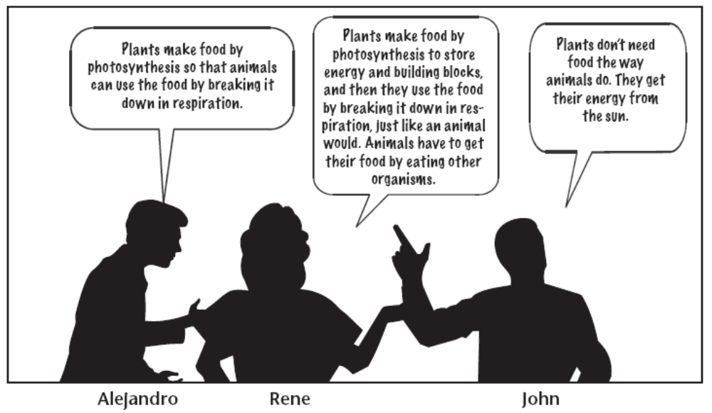
- Three students are discussing how plants and animals use food. Which student do you agree with? Explain your reasoning.

Activity 9: Photosynthesis or Cellular Respiration (optional inquiry)

General Overview:

This activity is a supplement to a plant growth inquiry you may already do. Recommended after Activity 3/4 or 5 depending on if you want to focus on cellular respiration or photosynthesis.

Purpose:
Students will use the process tool to predict what will happen when they manipulate the intensity of light, the amount of CO₂ or O₂ during photosynthesis or respiration.
--Photosynthesis is the process by which plants make their own food using simple molecules (CO2 and water) containing few chemical bonds to construct complex molecules (glucose) containing many chemical bonds. Energy is required for photosynthesis and is provided by sunlight.
--Respiration is the process that extracts bond energy from food and makes that energy available to perform cellular work. Energy is released during respiration. If you are doing a photosynthesis inquiry with your students before activity 5 (when cellular respiration is presented) you may wish to emphasize students use sufficient light to get a good amount of photosynthesis. If not, your students may measure cellular respiration and be confused because it has not been covered.

Materials:
Matter and Energy Process Tool
Materials you currently use to measure photosynthesis or respiration in your classroom (e.g. Floating spinach disks, Oxygen bubbles coming off Elodea (Anacharis), pH change with Elodea, Spinach (or other) leaves with gas sensors, germinating pea seeds).
Materials for students to manipulate requirement for photosynthesis or repiration.
Light intensity (40 W vs. 60 W light bulb or distance from light source)
Level of carbon dioxide (sodium biocarbonate for floating disks or oxygen bubbles or breathing into container for experiments with gas sensors)
Level of oxygen (burn match to decrease the amount of oxygen)
If you don’t already measure photosynthesis or cellular respiration, contact Jennifer Doherty (dohert59@msu.edu) and she can work with you for a solution for your classroom.

Advance Preparation/ Safety Considerations:

Detailed Procedures:
Have students use the process tool to predict what will happen when they manipulate the intensity of light or the amount of CO₂. An example is provided below.

Student Pages:

Student experiment is to measure photosynthesis in Elodea by counting the number of oxygen bubbles produced under intense light as compared to medium light.

First students use process tool to describe photosynthesis.

Light Energy Chemical Energy
Matter
Matter
Energy
Energy
Elodea Photosynthesis
Heat

Carbon Dioxide Glucose
Water Oxygen

Then students should use the process tool to predict and explain what will/did happen when they performed their experiment. They should do this by tracing matter and energy through the process tool. “When light energy in increased the amount of carbon dioxide and water turned into glucose and oxygen should increase. This will lead to an increase in the storage of chemical energy in the elodea and an increase in heat created. Therefore, I predict I will see more oxygen bubbles in the higher amount of light.”

Some vitamin pills include fillers that have calories and will burn (sugar, starch, oil). Avoid these types of pills.
Alternatively, you can use glucose test strips without heating the sample (urine analysis strips for diabetes monitoring) and each student can participate in testing for sugar. You can get these strips from Carolina.com or Cliawave.com, some pharmacies may also carry them.
You can buy glucose tablets for diabetics in your local pharmacy or glucose granules in a cake decorating store.
You can also purchase Iodine Tincture or Povidone-Iodine from your local pharmacy
Dropper bottles are preferred as students are less likely to spill iodine which stains clothes and hands.
To simplify the physical procedures, students can weigh the envelopes before they add the wet plants and then subtract that weight from the weight of the dry plants and envelope. This decreases the chance of students loosing plant tissue when they pour the dry plants into the weigh boats, however, there is more math and the logic of taring.
Some vitamin pills include fillers that have calories and will burn (sugar, starch, oil). Avoid these types of pills.
The equation in this handout simplifies the process of photosynthesis in plant leaves. A more accurate equation would be 12 H₂O + 6 CO₂ → C₆H₁₂O₆ + 6 O₂ + 6 H₂O. All of the oxygen atoms that are released into the atmosphere as O₂ come from water molecules, while the oxygen atoms in CO₂ go into glucose and water molecules. Our judgment is that this detail, like the stages in light-dependent and light-independent reactions, can reasonably be left to a more advanced class.
Photosynthesis can occur in any cell that contains green chloroplasts. Therefore, green stem and fruit cells can also make sugar. The potato model allows you to talk about chloroplasts if you wish.
Alternatively, you can use glucose test strips without heat the sample (urine analysis strips for diabetes monitoring) and each student can participate in testing for sugar. You can get this strips from Carolina.com or Cliawave.com, some pharmacies also may carry them. You then don’t need to dilute the carrot juice.
You can buy glucose tablets for diabetics in your local pharmacy or glucose granules in a cake decorating store.
You can also purchase Iodine Tincture or Povidone-Iodine from your local pharmacy
Dropper bottles are preferred as students are less likely to spill iodine which stains clothes and hands.
Not addressed in this unit: when organisms bond two sugar monomers to build a polymer, a molecule of water is produced.

